**Start-up Marketplace**

**Synopsis**

The main aim of this site is to popularize small businesses that would otherwise go unnoticed. These enterprises often find it difficult to reach out to potential customers and hence fail to reach their full potential. Our site acts as the middleman, providing a platform to link the producer and their target customers.

**Business Model**

Provider: The provider makes products which he is can host on the site. Each provider has a Business Page with the list of products/services that it provides as well as the contact details.

Customer: The customer can access the site and browse the list of services. If he is interested in purchasing products from a business site, he is provided with the suitable contact details to notify and place the order with the business.

Our Site: The site is responsible for connecting the above two entities. The site categorizes the providers and provides ratings and reviews to help the customer decide which services are suitable for him. Providers can be suggested to the customers based on his location as well. Providers are notified of the interested customers and can redirect them to their website to complete the transaction. Payment cannot be made through the site.

**Features:**

Authenticating Businesses: Businesses must register themselves with a valid email and password in order to use the site to display their products.

Business Pages: Providers will be given an interface to post, delete, or modify the list of available products/services currently offered by them. Only the authorized businesses will be able to modify their product listings. The page will also display their contact details and any external websites they might have.

Listing Details: The provider must provide the following details to list a product:

* name
* price
* picture
* description

Business Inbox: The orders/inquires made by the customers are forwarded to the business's inbox. This provides a medium for communication.

User Registration: The users must provide the following details on sign up:

* Name
* email
* Phone number
* Shipping address

Categorization and Searching: Providers will be grouped and organized based on the products/services they provide. The customers can search for the suitable businesses using a keyword based search.

Ratings and reviews: Customers are given the opportunity to rate their experience with the provider as well as post reviews on each product.

Location-Specific Content: Customers can filter providers based on their location.

**Wireframes:**

The following wireframes provide a basic conceptual view of the site:

**Homepage**:

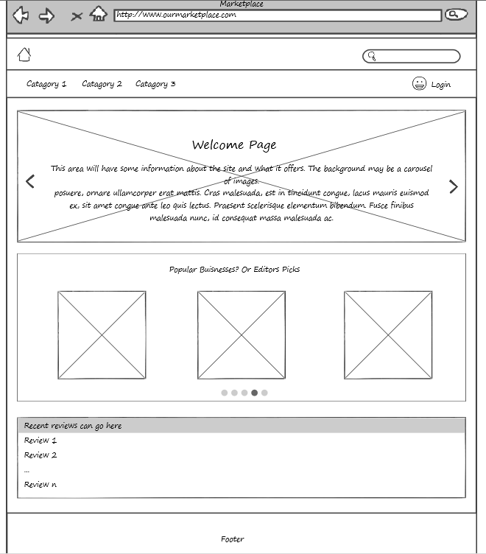

**Business Page:**

